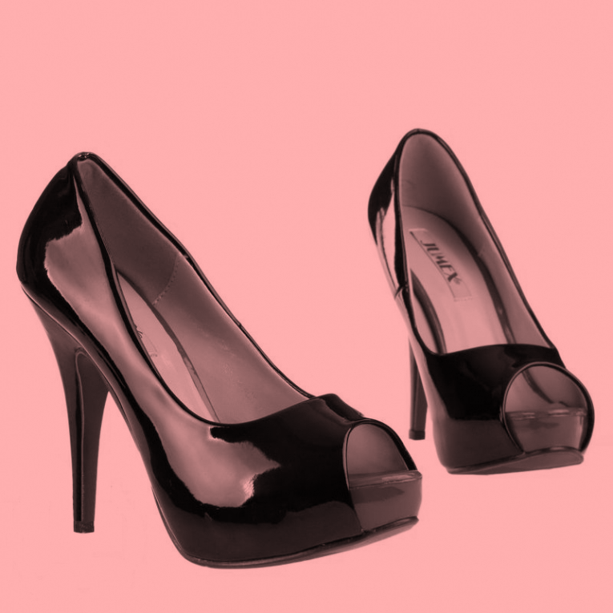
Top 10

- Nail-polish is going to be very hot this summer, if you find one color borring chose two colours, chose triking colours: pink, green, gold,…
- Make every day a special day, chose some flashy pants, but if you don’t now what to wear chose some black clothes.
- Chose some accesoires to make your clothes more beautiful.

